Safe Recruitment Process

Policy and Procedures

Master Kindred Martial Arts (MKMA Karate)

Written: 7th April 2021

To Be Reviewed with Intervals No Greater Than 2 Years

Reviewed last: 30/09/2026
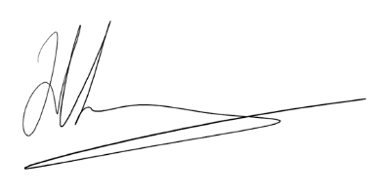
Reviewed By: J. Rowberry
Signature:

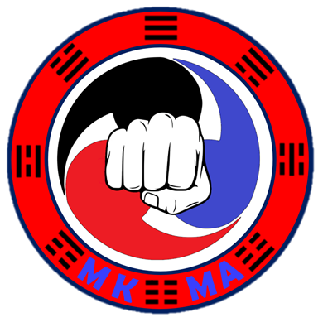

Safe Recruitment Process

MKMA Karate are committed to providing a thorough recruitment process to ensure the safe and effective instruction of all our members. Below outlines this process.

- Student informs instructor they wish to become an instructor and is recommended by their instructor or student is recommended by their instructor and wishes to become an instructor.

- Student has meeting with the MKMA Chief Instructor/Assistant Chief Instructor/Admin Team to discuss suitability, the application process, and the job role.

- Student completes the required training outlined in the MKMA instructor application form.

- *DBS form is completed (Online Via BMABA) and submitted
4a) Should a DBS return conviction, these should be reviewed, and if relevant, a risk assessment put in place. Consider rejection of application.

- Student submits the MKMA Karate policies sign-off form along with evidence of course completion including safeguarding and first aid.

- Full application is reviewed by MKMA Admin team

- Decision Made:
Instructor Applicant
Final approval
Application accepted
Application refused
Gains provisional instructor status
Opportunity to reapply if appropriate
Minimum of four classes Supervised
Instructor card Issued
Feedback given to
applicant

-
Obtaining a DBS

*Should the Instructor Applicant already hold a Valid Enhanced DBS from another organisation held on the DBS Update Service, this can be submitted as evidence. MKMA Karate needs the following details to run the DBS Check through the Update Service:

- Certificate Number
- Surname on Certificate
- Date of Birth

MKMA Karate uses the British Martial Arts and Boxing Association (BMABA) to process the DBS certificates of it’s Instructors.

The Cost
Due to the nature of martial arts and the close instruction and supervision of children, MKMA Karate require every instructor to hold a valid Enhanced DBS. The cost of a DBS is £45 with a processing cost of £20 meaning a total cost of £65 although this price may vary slightly.

